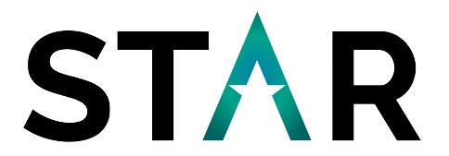
Social Value Case Study
Short Breaks for Children with Disabilities
What was the project?  Holiday activities to be delivered to children and young people with additional needs. This is a sports based activity where young people can attend between the hours of 10am – 3pm. | 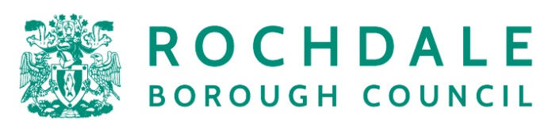
Outcomes
Below lists some of the key measures that were committed to as part of the procurement:
- Local employment
- Apprenticeships and education
- VCSE and local supply chain spend
- Volunteering
Project Team
Rochdale Council: Early Help and Schools
STAR Procurement: Shirella Simms
How were the Social, Economic & Environmental Issues (“Social Value”) Addressed?
Prior to procurement, Rochdale Council and STAR Procurement reviewed how this would align with the Corporate Priorities. Additionally, the procurement project addressed the following considerations within the Greater Manchester Social Value Policy:
- Promote employment and economic sustainability
- Raise the living standards of local residents
- Promote participation and citizen engagement

STAR conducted an open procurement process which was advertised. The award criteria was discussed and agreed, and due to the importance the project team applied to Social Value in terms of benefits to the local community and economy a Social Value weighting was set at 20% of the overall score.

The winning tenderers’ social value responses and outcomes have been managed via the Social Value Portal.

The overall social value committed from the procurement was £67,984 as based on the Social Value Themes, Outcomes and Measures (TOMS). To date, this has been exceeded and currently stands at £79,466 which is a 16.89% increase.
Want to know more?  E-mail Us or phone us: 0161 912 1616 | Lessons Learned  This procurement demonstrated that added value can be extracted from procurement projects which affects both citizens and the local community.
Leading transformation through procurement and cooperation

